**KUOYO KOCHIA BOYS’ HIGH SCHOOL**



**FORM TWO**

**COMPUTER STUDIES**

**NAME ___________________________________ ADM NO_________ Stream______ Date _________**

**451/1**

**Computer studies**

**Term 2 2025**

**TIME: 2HOURS**

**MID-TERM TWO EXAMINATIONS 2025**

**INSTRUCTIONS TO THE CANDIDATES**

1. *Write* ***your name*** and ***stream*** *and* ***Admission number*** *in the spaces provided above*
2. *Answer* ***all*** *the questions in* ***in this paper***
3. *All answers MUST be written in the spaces provided on this question paper.*
4. *This paper consists of 7 printed pages. Candidates should check carefully to ascertain that all the pages are printed as indicated and no questions are missing.*
5. *Candidates should answer the question in English*

**FOR EXAMINERS” USE ONLY**

|  |  |
| --- | --- |
| **MAXIMUM SCORE** | **CANDIDATE % SCORE** |
| **100** |  |

1. a) Define the term booting as used in computers. (1 mark)

________________________________________________________________________________________________________________________________________________________________________________________

b) State **TWO** ways of warm booting a computer. (2 marks)

________________________________________________________________________________________________________________________________________________________________________________________

1. Computers can be classified into different categories based on various parameters. One of these parameters is **functionality**, explain how computers are classified based on functionality, use diagrams where necessary.

(6 marks)

________________________________________________________________________________________________________________________________________________________________________________________________________________________________________________________________________________________________________________________________________________________________________________________________________________________________________________________________________________________________________________________________________________________________________

1. List **TWO** factors to be considered when purchasing computer hardware. (2 marks)

________________________________________________________________________________________________________________________________________________________________________________________________________________________________________________________________________________________________________________________________________________________________________________

1. a) Briefly explain the meaning of the term **computer laboratory. (**2 marks)

____________________________________________________________________________________________________________________________________________________________________________________________________________________________________________________________________________________

b) Explain why gaseous fire extinguisher is preferred over the Water and powder fire extinguisher in a computer laboratory. (2 marks)

________________________________________________________________________________________________________________________________________________________________________________________________________________________________________________________________________________________________________________________________________________________________________________ c) State any **TWO** factors to consider when setting up a computer laboratory. (2 marks)

________________________________________________________________________________________________________________________________________________________________________________

1. Write the following acronyms in full as used in computer science. (3 marks)
2. MICR: _________________________________________________________
3. UPS: __________________________________________________________
4. ALU: __________________________________________________________
5. Mention **THREE** reasons why a calculator is a computer. (3marks)

________________________________________________________________________________________________________________________________________________________________________________________________________________________________________________________________________________________________________________________________________________________________________________

1. a) What do you understand by the term a **microcomputer**. (1 mark)

________________________________________________________________________________________________________________________________________________________________________________________________________________________________________________________________________________________________________________________________________________________________________________

b) State and explain any **TWO** microcomputers that you know. (4 marks)

________________________________________________________________________________________________________________________________________________________________________________________________________________________________________________________________________________________________________________________________________________________________________________

1. State four categories of keys on the computer key board. (4 marks)

________________________________________________________________________________________________________________________________________________________________________________________________________________________________________________________________________________________________________________________________________________________________________________

1. State **FOUR** major classifications of Computer hardware. (4 marks)
2. _____________________________________
3. _____________________________________
4. _____________________________________
5. _____________________________________
6. a) Define the term **Operating System** as used in computers. (1 mark)

________________________________________________________________________________________________________________________________________________________________________________________

1. What are the **THREE** ways used to classify the operating system. (3 marks)

________________________________________________________________________________________________________________________________________________________________________________

1. The figure below shows an extract from a computer program.

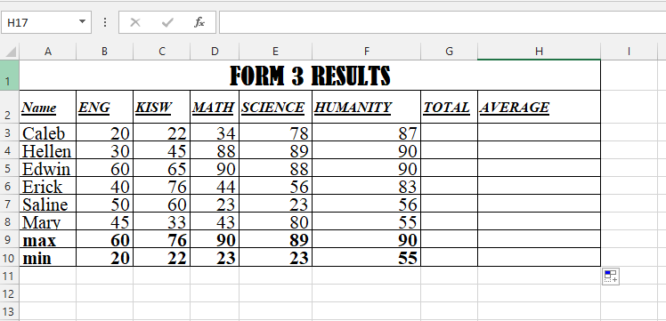

1. Name the program from which the extract above was taken. (1 mark)

____________________________________________________________________________________

1. Define a **cell** as used in the program shown above. (1 mark)

____________________________________________________________________________________________

1. State **FOUR** formatting features used in the extract above. (4 marks)
2. _____________________________________
3. _____________________________________
4. _____________________________________
5. _____________________________________
6. Write the function the that can be entered in to cell **G3** AND copied downwards to calculate the TOTALS **(2 marks)**

_____________________________________________________________________

1. Write the function the that can be entered in to cell **H3** AND copied downwards to calculate the AVERAGE (1 mark)

_____________________________________________________________________

1. Give two reasons to justify why unstable power supply is considered a threat. (2 marks)

________________________________________________________________________________________________________________________________________________________________________________________

1. State **TWO** characteristics of Fifth generation computers. (2 marks)

________________________________________________________________________________________________________________________________________________________________________________________

1. a) What is a relational database management system? (1 mark)

________________________________________________________________________________________________________________________________________________________________________________________

1. a) A Macros, and a Module are examples of Database Objects, Other than these two, list any other **THREE** database objects (3 marks)
2. _____________________________________
3. _____________________________________
4. _____________________________________
5. _____________________________________
6. Differentiate between a **Macros** and a **Module** as used in Databases (2 marks)

_____________________________________________________________________________________________________________________________________________________________________________________________________________________________________________________________________________________________

1. Write the query criteria you would use to display employees details from a payroll database for employees who earn a basic salary that is Ksh. 12,000 and above. (1 mark)

_______________________________________________________________________________________

1. Describe the following mouse terminologies. (4 marks)
2. Clicking

_________________________________________________________________________________

1. Right- clicking

__________________________________________________________________________________________________________________________________________________________________

1. Double Clicking

_________________________________________________________________________________

1. Drag and drop

________________________________________________________________________________

1. The figure below shows an input device.
2. Classify the input device below (1 mark)

______________________________________________________________

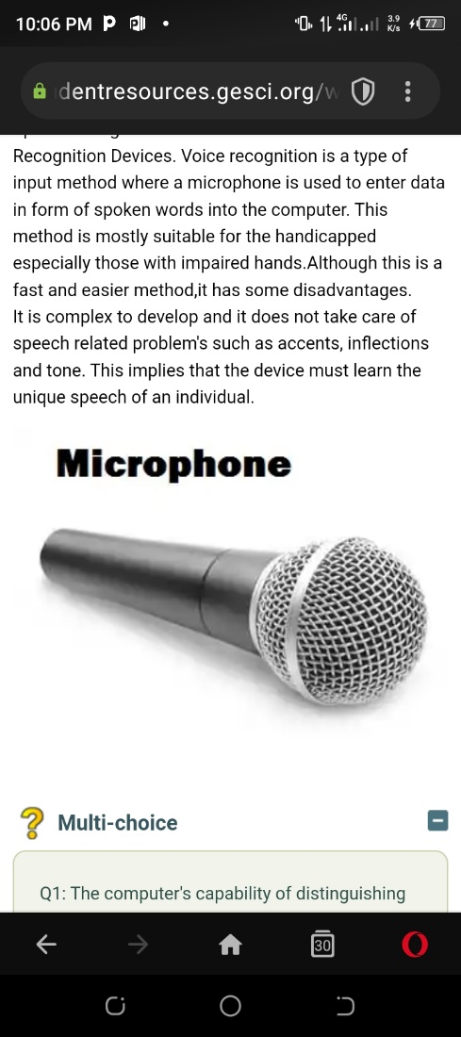

1. Highlight **TWO** advantages of using the device above (2 marks)

_____________________________________________________________________________________________________________________________________________________________________________________________________________________________________________________________________________________________

1. State TWO characteristics of the **RAM** (2 marks)

______________________________________________________________________________________________________________________________________________________________________________________________

1. List **TWO** types of RAM (2 marks)

______________________________________________________________________________________________________________________________________________________________________________________________

1. a) Differentiate between hardcopy output and a softcopy output (2marks)

____________________________________________________________________________________________________________________________________________________________________________________________

b) A monitor is one of the output devices. Below are some monitor displays

1. Identify the figures i and ii below ( 2 marks)

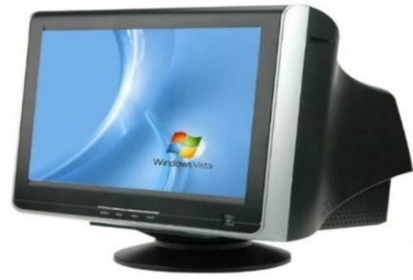

1. ___________________________

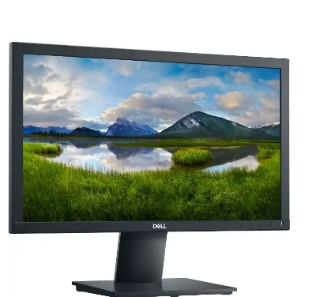

1. _______________________________
2. State THREE differences between the figure i and figure ii (3 marks)

____________________________________________________________________________________________________________________________________________________________________________________________________________________________________________________________________________________________________________________________________________________________________________________________

1. Give three examples of **figure ii** monitors available in the market today. (3 marks)

_____________________________________________________________________________________________________________________________________________________________________________________________________________________________________________________________________________________________

1. Differentiate between the **Save As** and the **Save** Command as used in Word Processors (2 marks)

______________________________________________________________________________________________________________________________________________________________________________________________

1. There are numerous Keyboard shortcuts in computer that are effective in Microsoft word. Explain What Can be achieved by the following Shortcuts in Microsoft word. (3 marks)
2. CTRL + B ______________________________________________________
3. CTRL + U ______________________________________________________
4. CTRL + A ______________________________________________________
5. What is the units for measuring the processor speed in computers? (1 mark)

________________________________________________________________________________

1. Mr. Wekesa went to a computer shop and saw a machine with the following specifications

$$500 GB HDD, 8GB, 19” 16.2GHz$$

Explain what these specifications mean (4 marks)

1. 500 GB HDD_________________________________________________
2. 8GB________________________________________________________
3. 19” ________________________________________________________
4. 16.2 GHz ____________________________________________________
5. Name four criteria used when selecting a printer. (4 marks)

____________________________________________________________________________________________________________________________________________________________________________________________________________________________________________________________________________________________________________________________________________________________________________________________

1. Pamtex construction company intends to buy an output device they can use to produce road maps. Which device would one advice the company to buy and why**?**  (2 marks)

_____________________________________________________________________________________________________________________________________________________________________________________________________________________________________________________________________________________________

1. Give three examples of operating systems**. ( 3 marks)**

_____________________________________________________________________________________________________________________________________________________________________________________________________________________________________________________________________________________________

**THIS IS THE LAST PRINTED PAGE**

**© 2025 Term Two mid-term exam**

**Kuoyo Kochia**